S2 B.Tech CSE
Department of Computer Science and Engineering
Amrita School of Computing, Amritapuri Campus
CASE STUDY
PHASE – 2 (Design)
Architectural Modelling (CO2)

Group No :
Team Members :
Roll No | Student Name
AM.SC.U4CSE25369 | P.ADITYA SAI RAGHAVENDRA
AM.SC.U4CSE25365 | M.GAUTHAM GOUD
AM.SC.U4CSE25364 | E.KUSHAL
AM.SC.U4CSE25303 | ANDE ROOP SRI SAGAR

- Problem Title :CAR RENTAL SYSTEM

STRUCTURAL DESIGN
- Class diagram (draw class diagram that shows different classes and their relationships. Use UML notations)
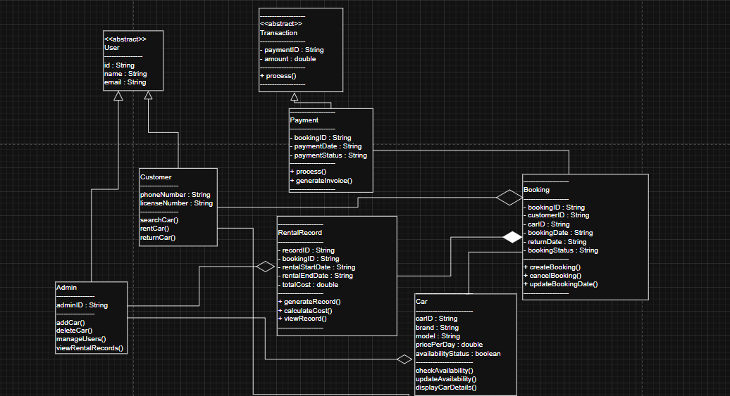
BEHAVIUORAL DESIGN
- Use-case diagram
- List of actors
1.Customer
2.Admin
- List of use-cases

- Search Car – Customer searches for available cars.
- Book Car – Customer reserves a car.
- Cancel Booking – Customer cancels booking.
- Make Payment – Customer pays rental amount.
- Return Car – Customer returns the vehicle.
- Add Car – Admin adds new vehicle.
- Remove Car – Admin removes a vehicle.
- Manage Users – Admin manages customer data.
- View Rental Records – Admin reviews rental history.
- Use case diagram (use UML notations)
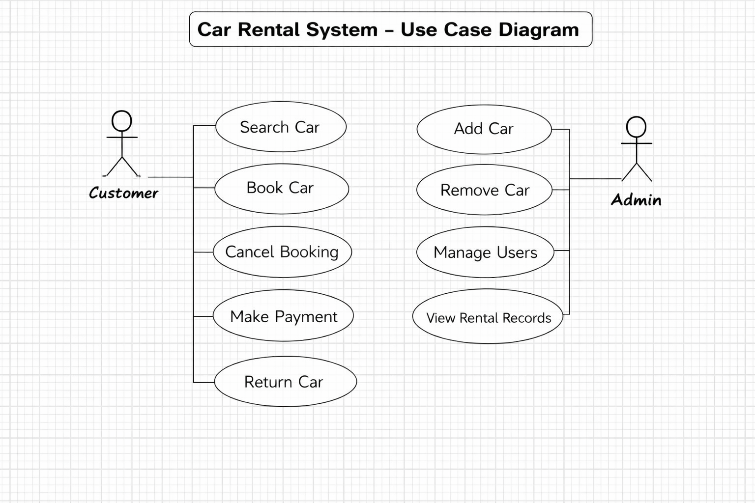

- Sequence diagram (use UML notations)
  - Choose key use cases and draw their sequence diagram. First describe the scenario in few sentences. Then draw the sequence diagram.
*.)Search and rent car:In this use case the customer searches for the car and book it and pays for it.
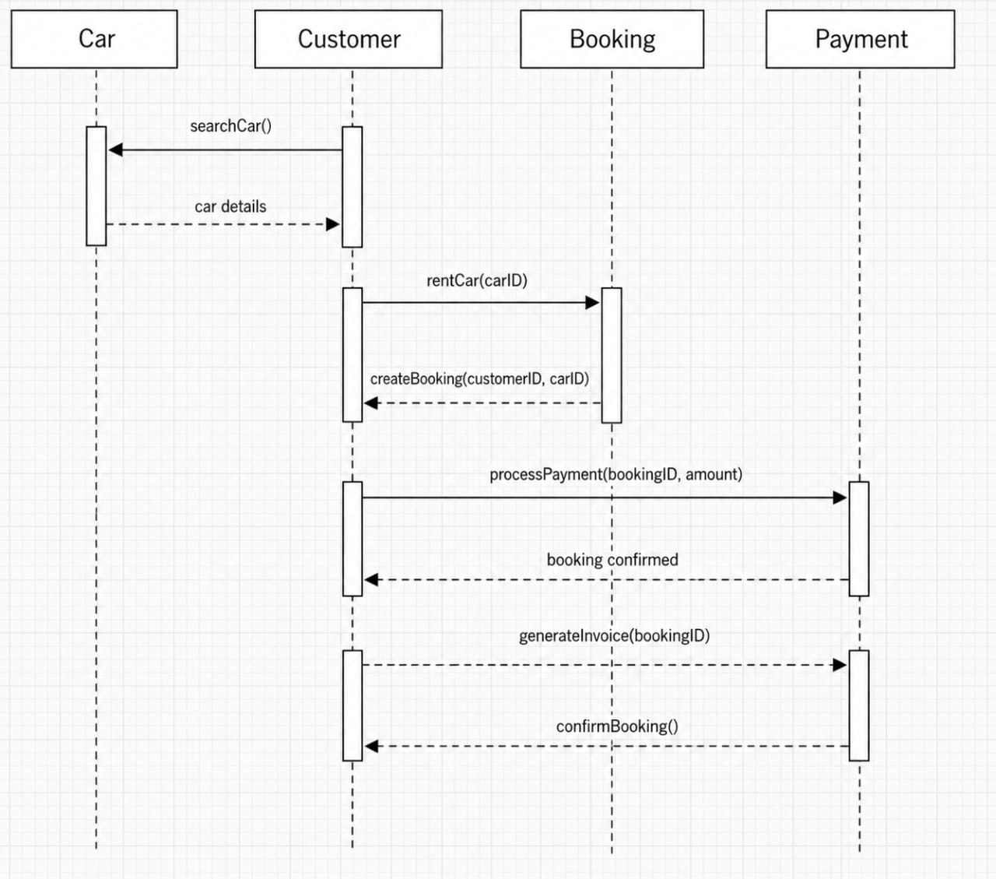

  - Choose key use cases and draw their sequence diagram. First describe the scenario in few sentences. Then draw the sequence diagram.
*.)Return car:In this use case the customer returns the car and the booking is updated and the rental cost is calculated
